EXEMPTION CERTIFICATE

DURING CURFEW HOURS
Pursuant to Article 4 of Decree No 2020-1310 of October 29 2020 providing for necessary general measures to cope with the spread of COVID-19, as part of the public health state of emergency
I, the undersigned,
Ms/Mr:
Born on:
In:
Address:
certify that my reasons to be outdoors match one of the following situations (check the box) authorised by the official measures to tackle the spread of Covid 19 as part of the public health state of emergency¹:
[ ] Commuting to and from work or university/place of training, business meetings/trips that cannot be delayed;
[ ] Consults and provision of care that cannot be performed remotely nor delayed;
[ ] Imperative family-related responsibilities, assisting vulnerable persons, persons in a precarious situation or looking after children;
[ ] Persons with a disability and their accompanying person;
[ ] Judicial or administrative summons;
[ ] Participating in a mission of general interest upon request from an administrative authority;
[ ] Air, rail or bus transit related to long distance journeys;
[ ] Walking a pet outdoors within 1km of one’s place of residence and for a brief amount of time.

Signed in
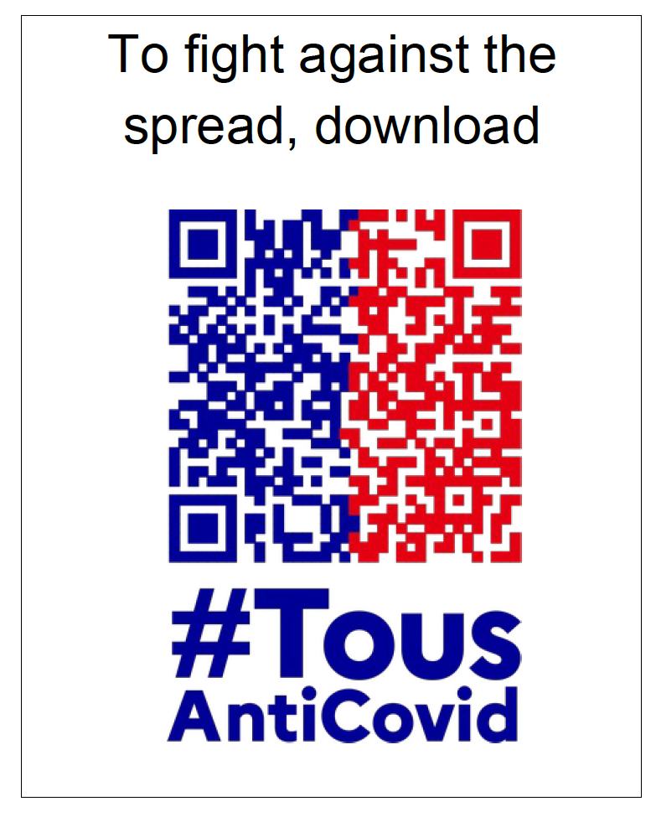
On: at:
(Date and hours are mandatory)

Signature:

1. People whose situation matches one of the aforementioned and can therefore be exempt must carry, when outdoors, written proof to justify that exemption.

